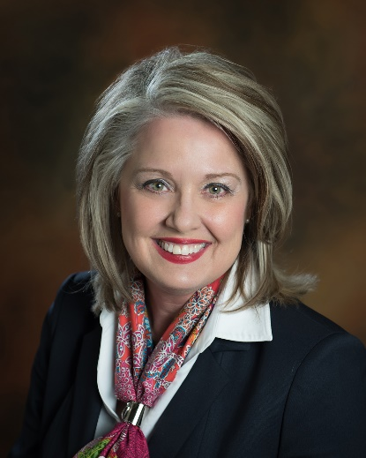
Kathy Fowler
Kathy Fowler Agency, LLC
123 S. 6th Street | P.O. Box 368 Memphis, TX 79245
kathy@proudtofarm.com
Office | 806-259-2626 Mobile | 580-481-0880
www.proudtofarm.com

Kathy Fowler of the Kathy Fowler Agency, based in the rural town of Memphis, Texas, in the southeast Texas Panhandle. The agency also operates two additional offices in Elk City and Altus, Oklahoma. All locations specialize in crop insurance, with property and casualty services added in 2015 to broaden the agency’s capabilities and better serve the needs of its clients and communities.
She is a fourth-generation farmer and grew up on a farm in western Oklahoma. To date, Kathy continues to farm cotton, wheat, and peanuts. Her passion for agriculture has led her to study each individual farmer and rancher’s business models to help mitigate risk and educate them on the latest programs and technologies. She and her team of twenty work hard to understand the ever-changing challenges facing Agriculture today.
Kathy has over 37 years of crop insurance experience and is committed to crop insurance being the cornerstone of the farm safety net. She strives to have positive political connections and, as a board member of CIPA, Crop Insurance Professionals Association, to help the agricultural community’s voice continue to be heard. She has testified three times before the House Ag Committee on the advancement of crop insurance.
Kathy has served as an alternate for Oklahoma on the Cotton Board, which is Cotton’s research and promotion program supported by producers and importers. She is currently serving as vice president of the Oklahoma Wheat Growers Association, with voting rights at the National Wheat Growers Association.
Kathy enjoys traveling with her two grandchildren, Kambell (16) and Jace (11) Fowler, who live in Houston, TX.

